Alan Thomas

CSI337-Information Sec.

Security Commands

Dr. Dutta

25FEB18

**Ifconfig**

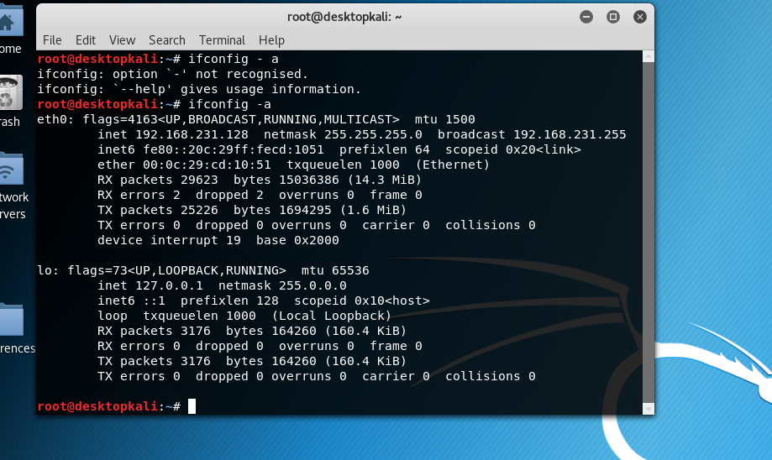

**Traceroute**

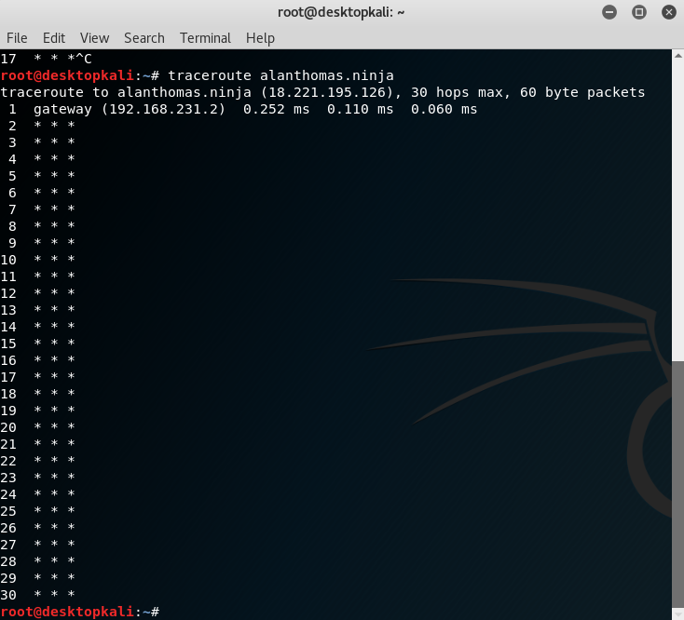

**Dig**

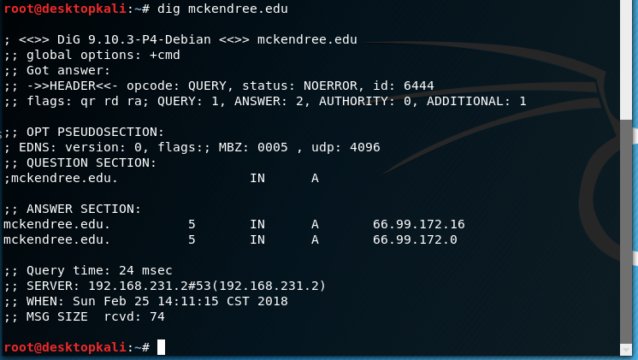

**Telnet**

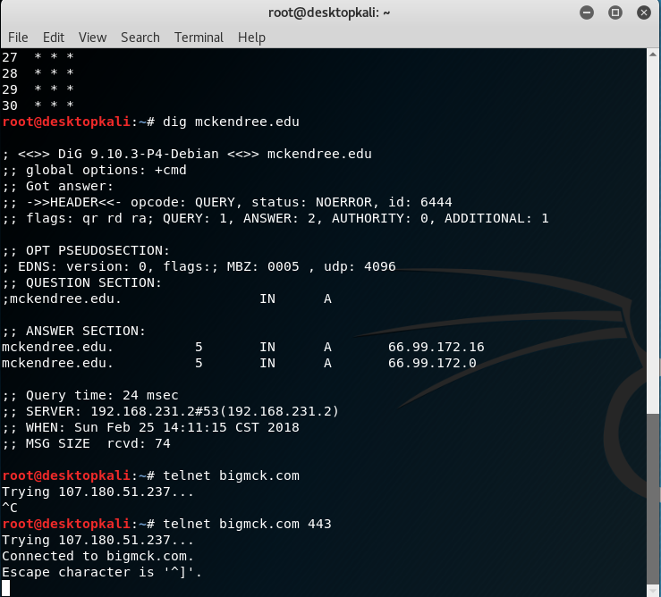

**Nslookup**

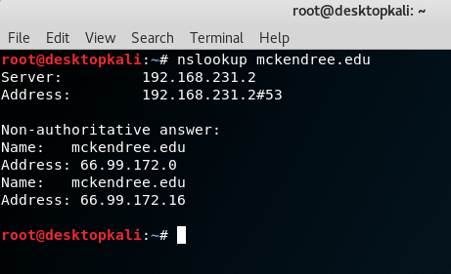

**Netstat**

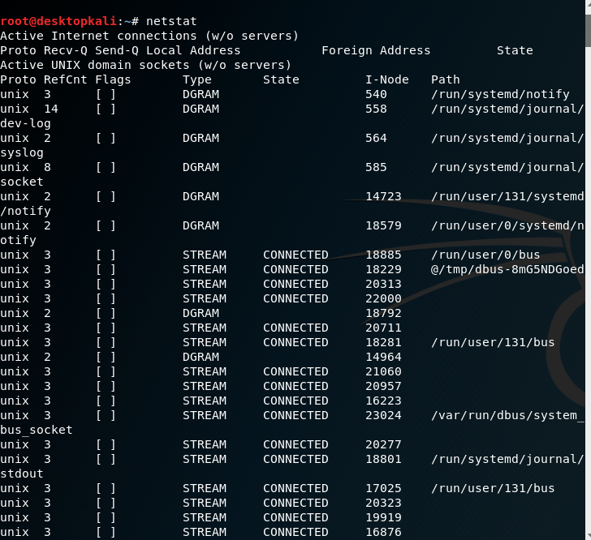

**Scp**

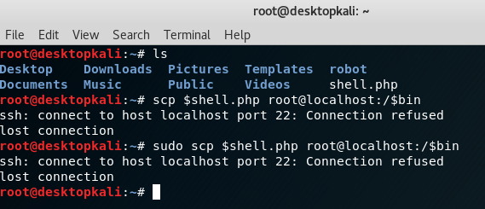

**W**

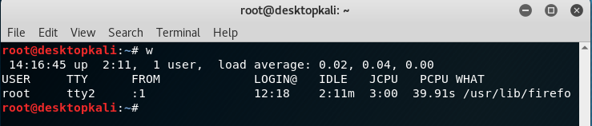

**Nmap**

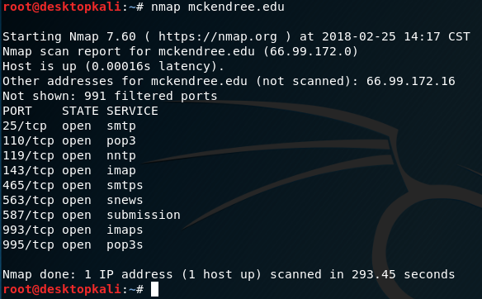

**Enable/Disable Network Interface**

I was not able to execute the ifup/down command due to the OS not detecting the interface despite listing it under the devices. However, I did some research and found that sudo ifconfig eth0 up/down works.



